Power Pages 1 Day

Power Platform WorkshopPLUS

Lab 3: Basic Forms, Lists and Security

Conditions and Terms of Use

Microsoft Confidential - For Internal Use Only

This training package is proprietary and confidential and is intended only for uses described in the training materials. Content and software is provided to you under a Non-Disclosure Agreement and cannot be distributed. Copying or disclosing all or any portion of the content and/or software included in such packages is strictly prohibited.

The contents of this package are for informational and training purposes only and are provided "as is" without warranty of any kind, whether express or implied, including but not limited to the implied warranties of merchantability, fitness for a particular purpose, and non-infringement.

Training package content, including URLs and other Internet Web site references, is subject to change without notice. Because Microsoft must respond to changing market conditions, the content should not be interpreted to be a commitment on the part of Microsoft, and Microsoft cannot guarantee the accuracy of any information presented after the date of publication. Unless otherwise noted, the companies, organizations, products, domain names, e-mail addresses, logos, people, places, and events depicted herein are fictitious, and no association with any real company, organization, product, domain name, e-mail address, logo, person, place, or event is intended or should be inferred.

© 2021 Microsoft Corporation. All rights reserved.

Copyright and Trademarks

© 2021 Microsoft Corporation. All rights reserved.

Microsoft may have patents, patent applications, trademarks, copyrights, or other intellectual property rights covering subject matter in this document. Except as expressly provided in written license agreement from Microsoft, the furnishing of this document does not give you any license to these patents, trademarks, copyrights, or other intellectual property.

Complying with all applicable copyright laws is the responsibility of the user. Without limiting the rights under copyright, no part of this document may be reproduced, stored in or introduced into a retrieval system, or transmitted in any form or by any means (electronic, mechanical, photocopying, recording, or otherwise), or for any purpose, without the express written permission of Microsoft Corporation.

For more information, see Use of Microsoft Copyrighted Content at

<http://www.microsoft.com/about/legal/permissions/>

Internet Explorer, Microsoft, Microsoft Dynamics, Microsoft Dynamics logo, and Windows are either registered trademarks or trademarks of Microsoft Corporation in the United States and/or other countries. Other Microsoft products mentioned herein may be either registered trademarks or trademarks of Microsoft Corporation in the United States and/or other countries. All other trademarks are property of their respective owners.

Table of Contents

Lab 3: Basic Forms and Lists 5

Part 1: Basic Forms and Security 6

Part 2: Lists and Security 16

# Lab 3: Basic Forms and Lists

Introduction

During this lab, you will be adding a new form to the 311 Power Pages to allow visitors to create and submit service tickets.

Objectives

* After completing this, you will be able to:
* Add forms to the Power Pages site
* Securing forms
* Validate records submitted via the Power Pages site
* Add lists to the Power Pages site
* Securing Lists

Prerequisites

* Completion of Lab 2

Estimated Time to Complete

* 30 minutes for the following steps

## Part 1: Basic Forms and Security

1. Navigate to <https://make.powerpages.microsoft.com> and ensure you are in the Pages 1 Day Dataverse environment.
2. Select **Pages** via the left navigation bar, then select **+ Page > Standard Layouts > Page.**
3. Set the page name as **Submit New Ticket** and click **Add.**
   1. A new web page will be created
4. Replace the sample header text with “Submit New Ticket” and replace the sample body text with "To request non-emergency services from Anytown 311, please fill out the form below." Center both texts utilizing the options bar that appears.

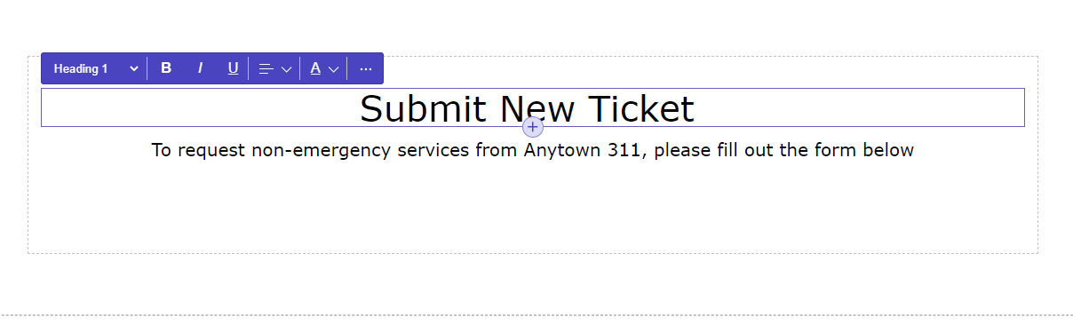

1. Hover your mouse over the dotted lines between the first and second sections. A circular button with a “**+**” will appear. Click on this button.
2. Section layout options will appear. Select **2 Column**.

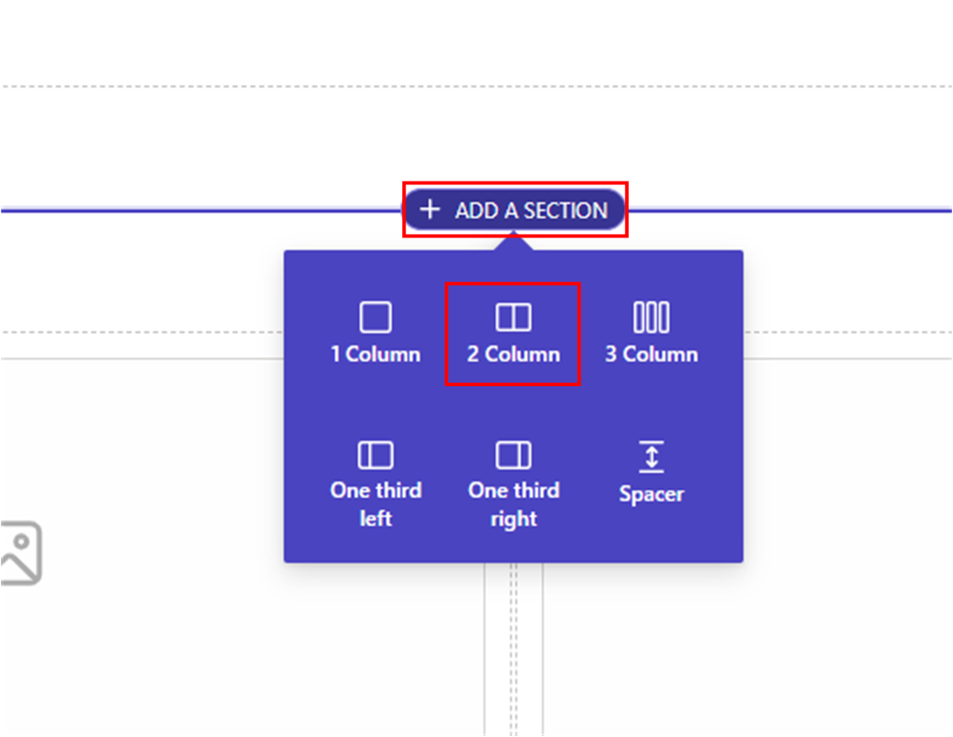

1. On the left column, select the ellipses (…) and then select **Form.**

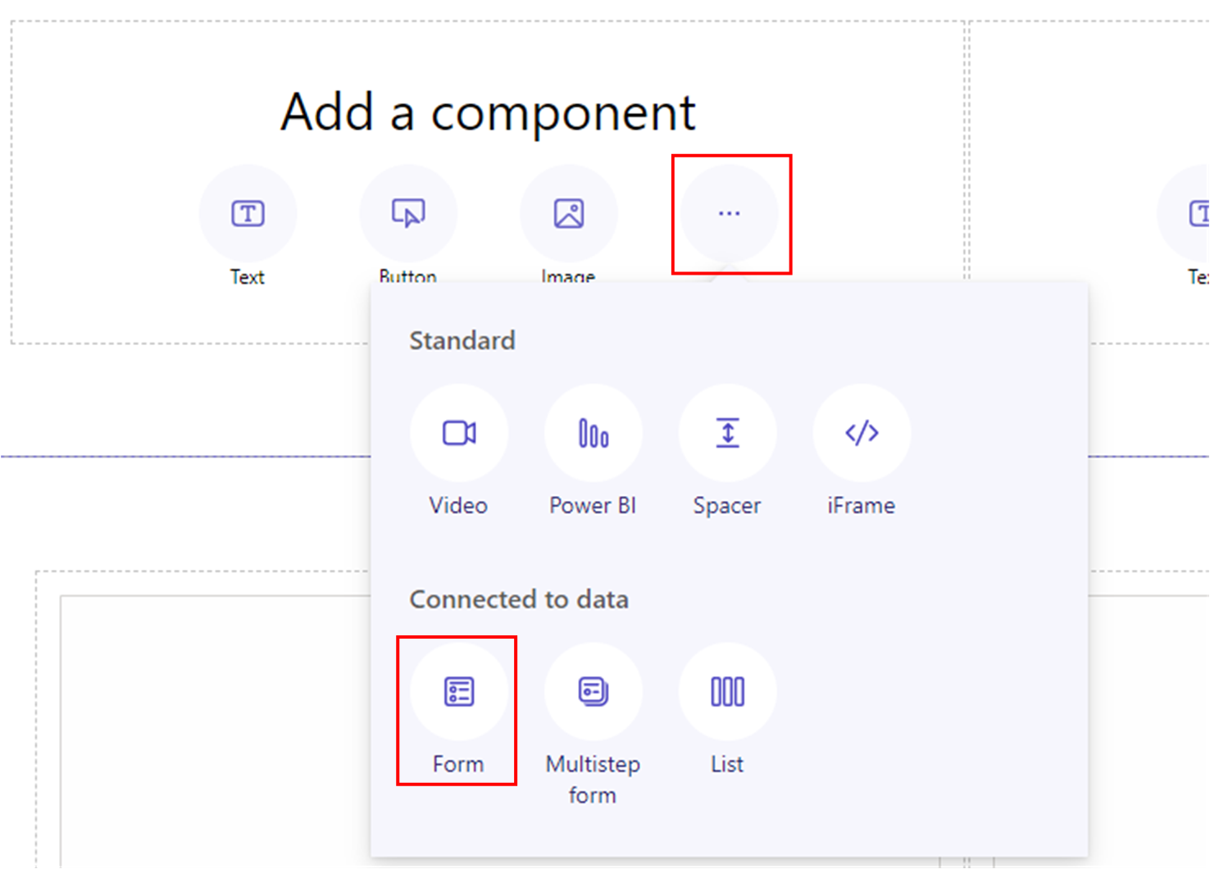

1. In the pop-up window, select **+ New Form.**
2. Enter the following information:
   1. Choose a table: Ticket (ce_ticket)
   2. Select a form: Portal – Create
   3. Name your copy of the selected form: New Ticket

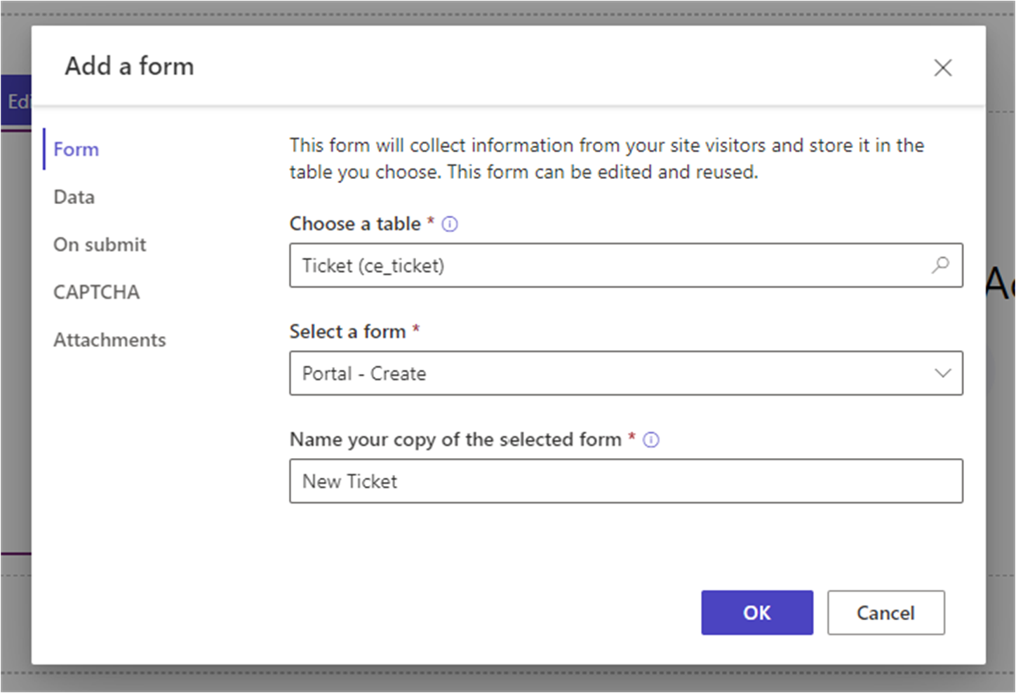

Note: You will not see the **Ticket** table as an option if you have not already installed the managed solution as a part of your workshop setup. If that is the case, please go back to the **Pages Setup Guide** and navigate to and complete the section **Install managed solution**.

1. Observe the default information in the **Data,** **On submit, CAPTCHA,** and **Attachments** tabs of this window.
2. Click **OK.**
3. Navigate to the **Set up** tab via the left navigation bar, then select **Table Permissions** beneath **Security**.

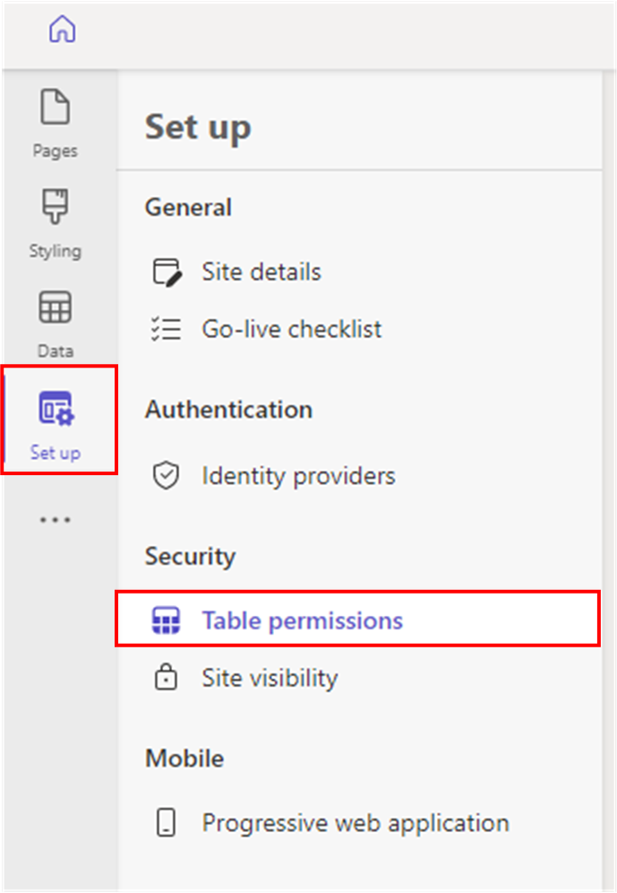

1. Click **+New permission.**
2. Enter the following information:
   1. Name: Tickets – All Users
   2. Table: Ticket (ce_ticket)
   3. Access type: Contact access
   4. Relationship: ce_Ticket_Submittedby_Contact
   5. Permission to: Read, Write, Create, Append, Append to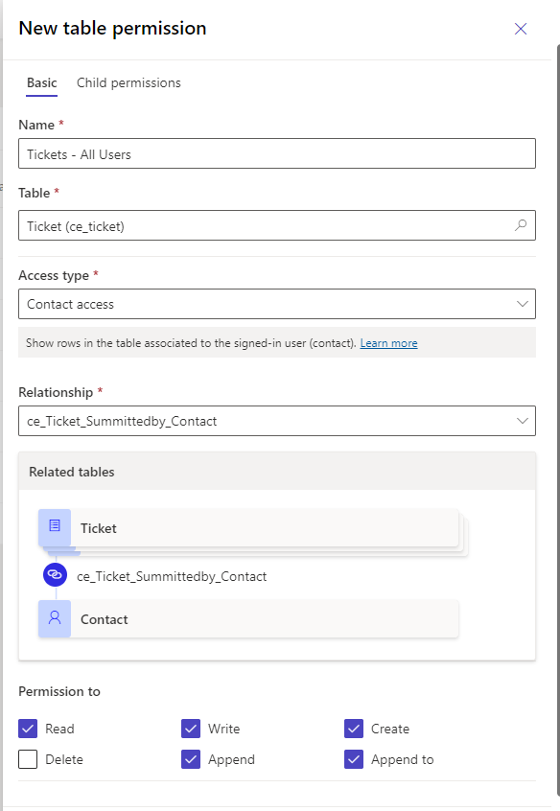
3. Still in the New table permission form, scroll down to **Roles** and select **+ Add roles**.
4. Check the boxes for **Anonymous Users** and **Authenticated Users.**

1. Click **Save.**
2. From the left navigation bar, select **Pages.**
3. Open the newly created Submit New Ticket page, then highlight the form that was just added.
4. Select **Edit Form.**

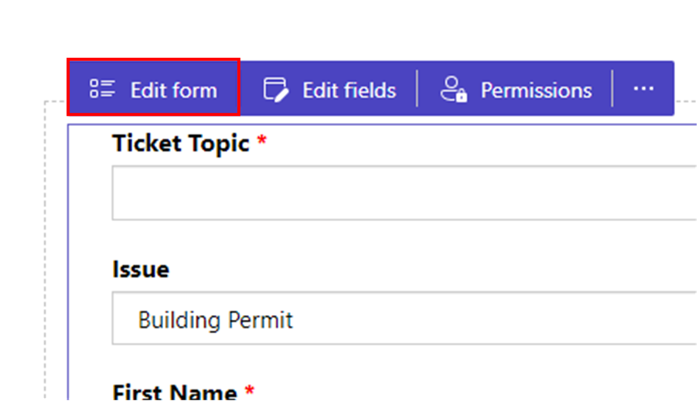

1. Navigate to the **CAPTCHA** tab and uncheck **Show CAPTCHA for authenticated users**.

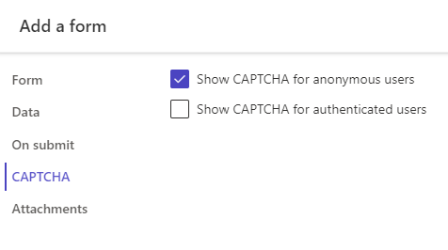

1. Click **OK.**
2. Select the Image component on the right column of this section. Insert an image of your choosing.
3. Click **Sync** in the top right corner, then select **Preview > Desktop**.

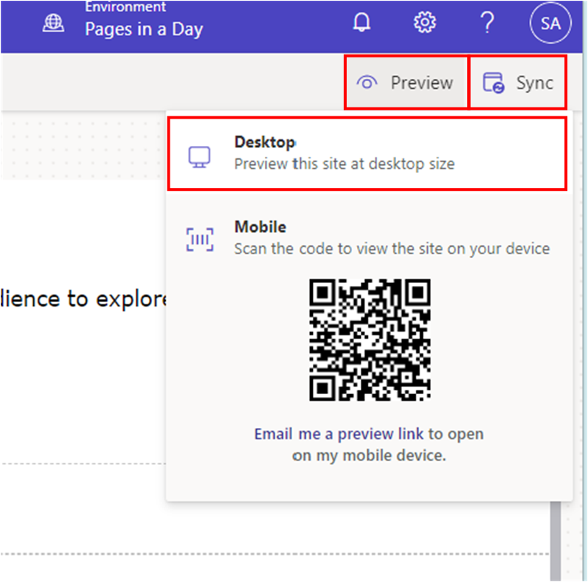

Expected result:

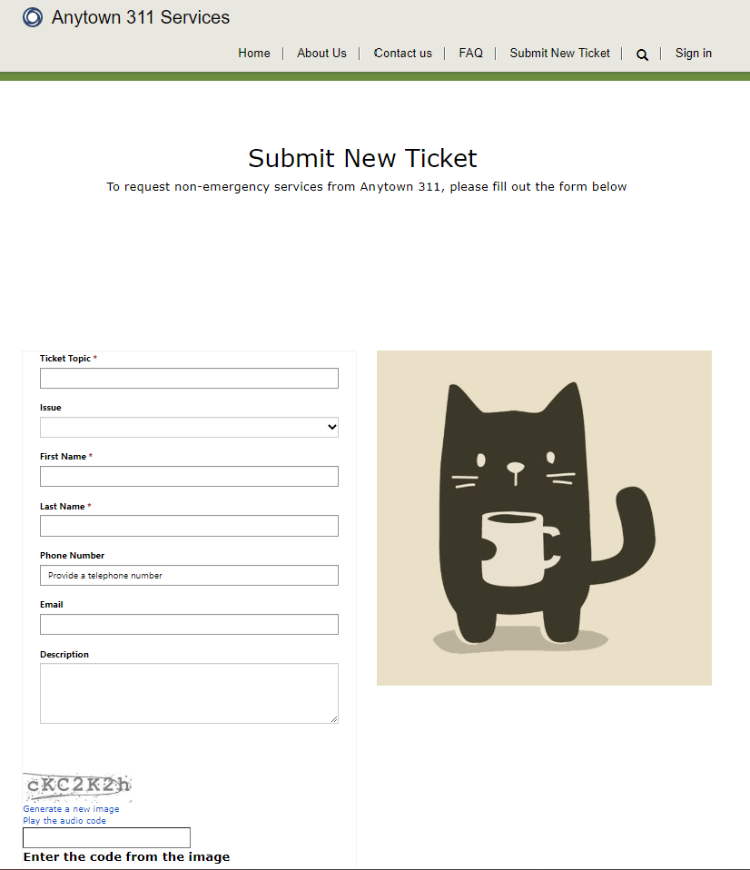

1. Fill out the requisite fields in the form and click **Submit**.

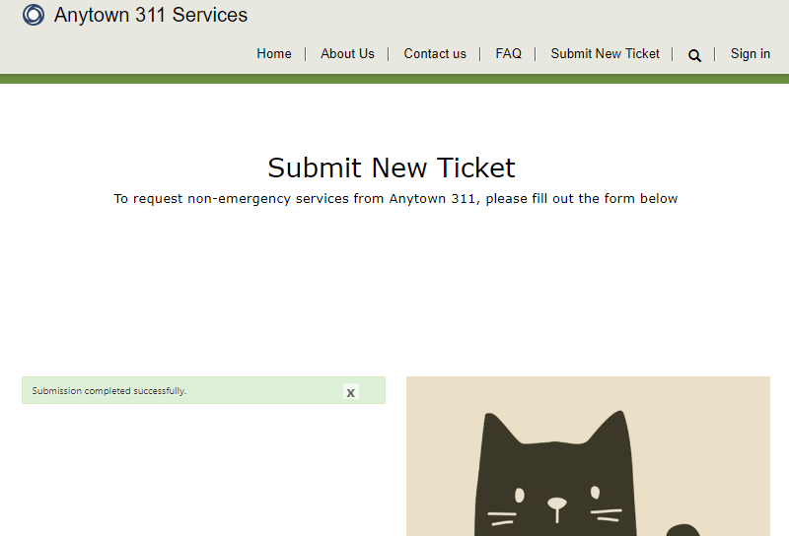

1. Navigate to make.powerapps.com, select the appropriate Dataverse environment—not default.
2. Navigate to **Apps** in the left navigation bar and identify the **Anytown 311** model-driven app. This was installed as a part of the managed solution and is where Anytown’s employees would be able to see submitted tickets and other data submitted from the site. Click on its name to open it.

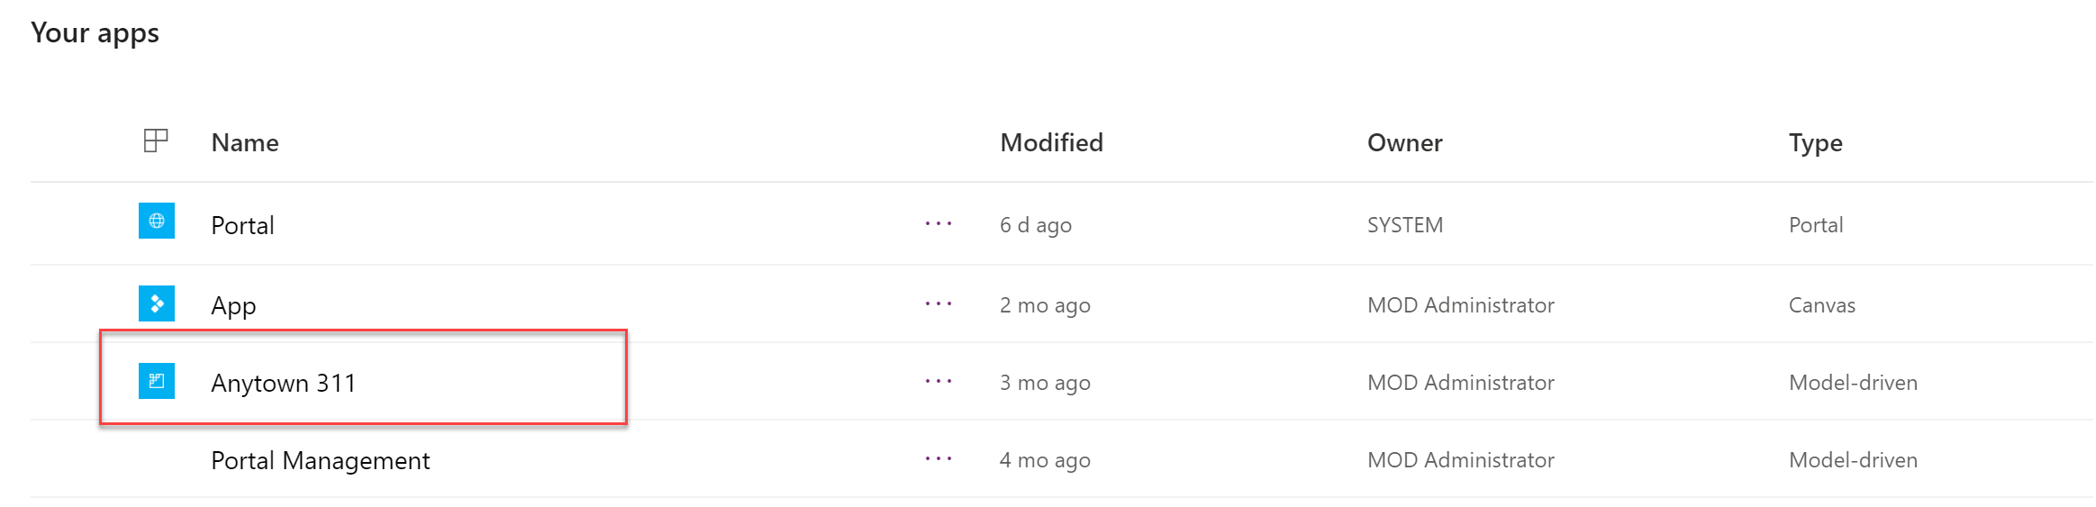

1. From the left navigation click on **Tickets:**
   1. Note: The submitted ticket from the site is visible in the view.

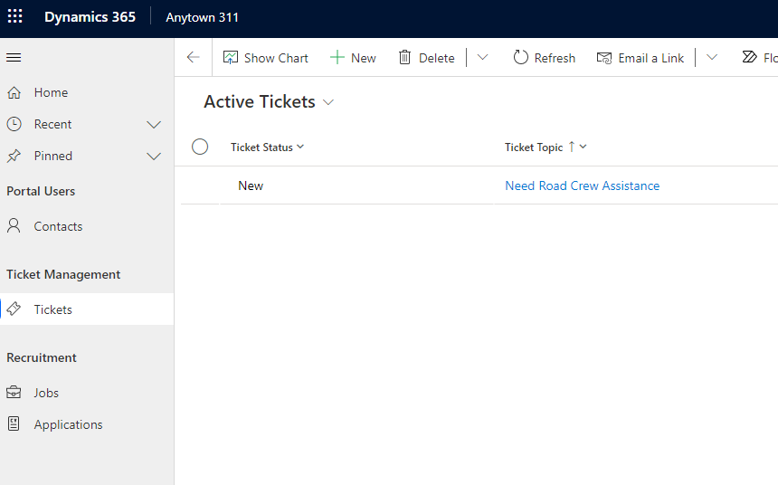

1. Click on the record’s name to view the details:
   1. Note: As an internal user, you can change the ticket's status field in the top right corner.

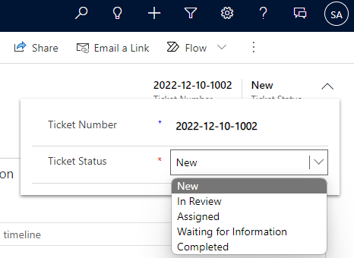

## Part 2: Lists and Security

1. While still in the **Anytown 311** model-driven app, navigate to and select the Jobs tab from the lefthand navigation.
2. Select the **+New** button in the ribbon bar and complete the form to create a new job. Feel free to add a few!
3. Navigate to <https://make.powerpages.microsoft.com>. Ensure that you are not in the default environment.
4. Click **Sync** in the upper right corner.
5. Click **+ Page > Standard Layouts > Page.**
6. Set the page name as **Open Positions** and click **Add.**
7. Modify the sample text on the page to "Thank you for your interest in working with us at Anytown! Vacant positions within the city are listed below". Center both texts in this section.
8. Hover your mouse over the dotted lines between the first and second sections. A circular button with a “+” will appear. Click on this button.
9. Section layout options will appear. Select **1 Column**.

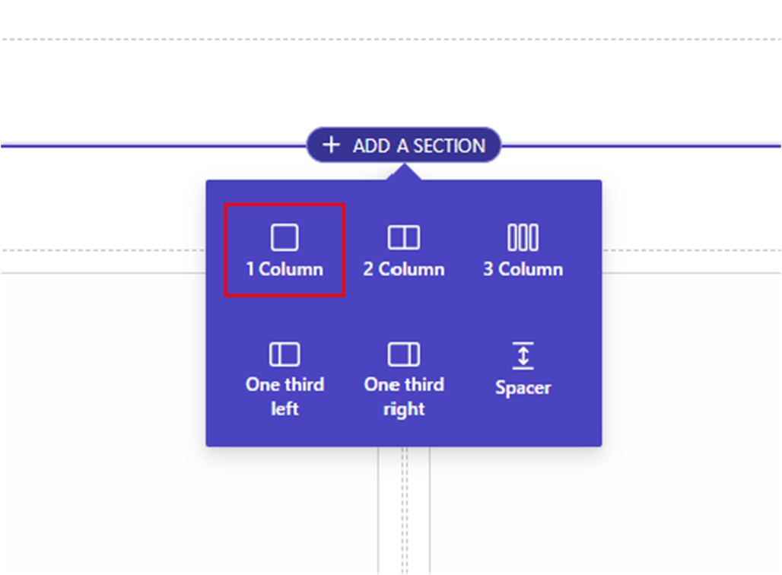

1. Select the third section, the one below your newly added section. In the options bar, select the ellipses **(…)** and click **Delete** to remove this extra section.

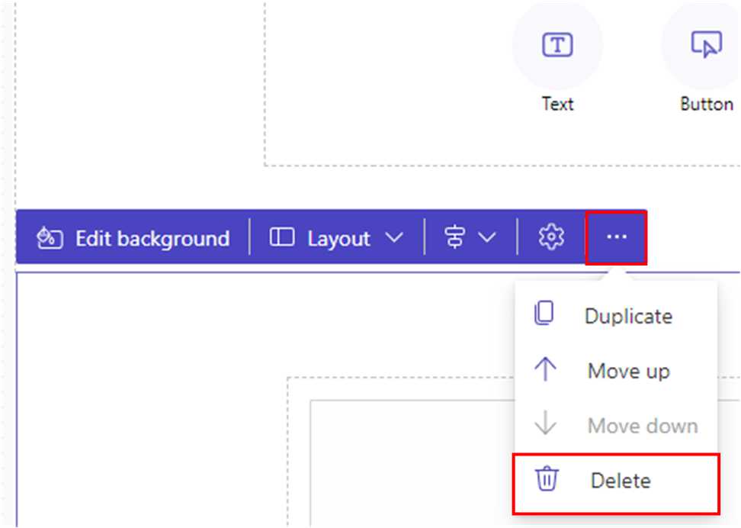

1. In the newly added section, select the **List** component.

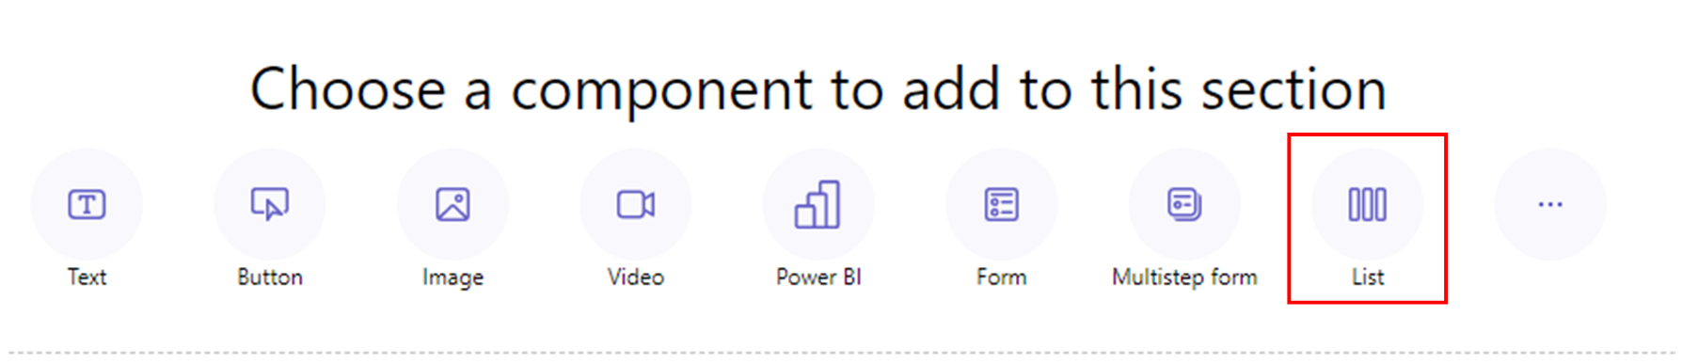

1. Enter the following information:
   1. Choose a table: Job (ce_job)
   2. Select Dataverse views: Active Jobs
   3. Name your copy of the selected list: Available Jobs

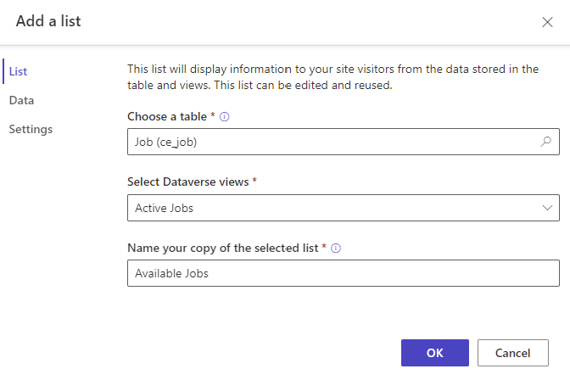

1. Click **OK.**
2. Above your newly added list, select **Permissions** in the options bar.

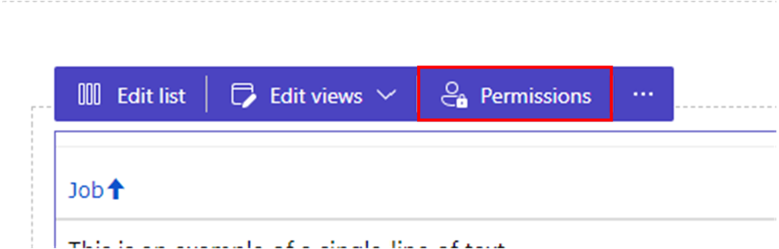

1. Select **+ New permission** in the right window.

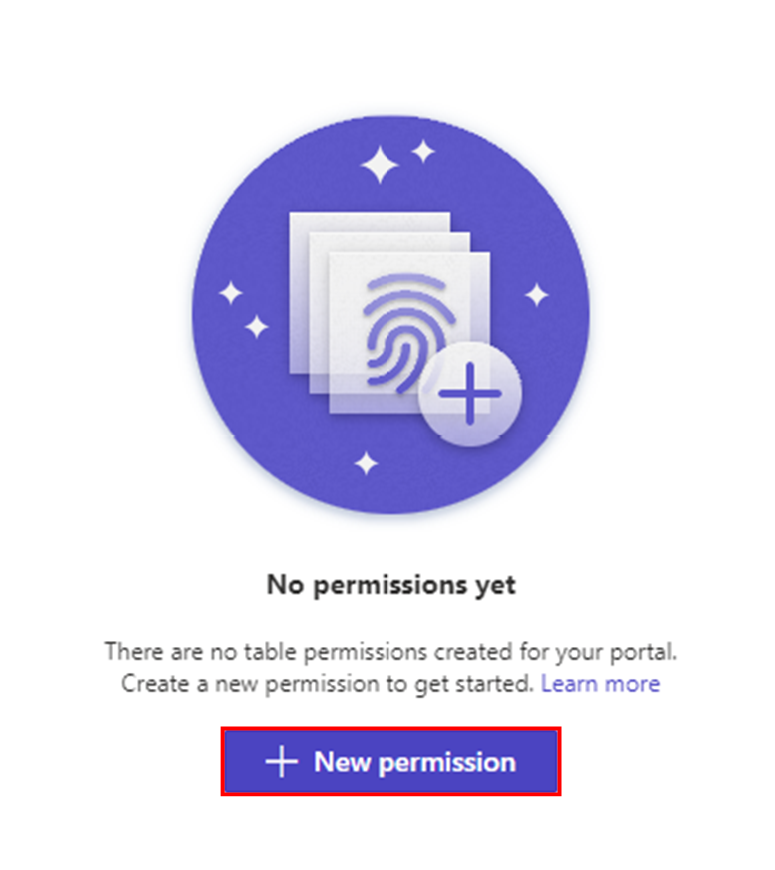

1. Enter the following information:
   1. Name: Open Positions – Anonymous Users
   2. Table: Job (ce_job)
   3. Access type: Global
   4. Privileges: Read
   5. Roles: Anonymous Users

1. Click **Save.**
2. We will now have to create a Form for later use. In any available section on the screen, hover your mouse over the circular button with a “**+**” in the center. Click on this button. Select **Form**.

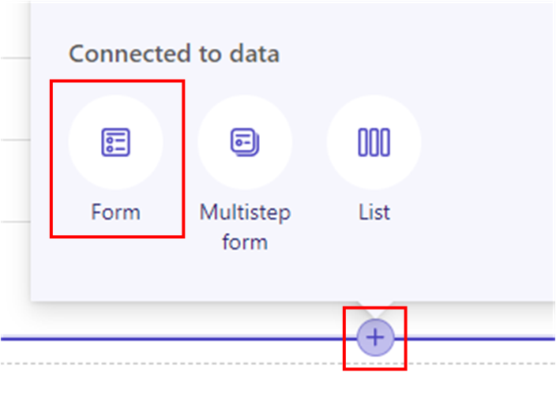

1. Click **+ New form**.
2. Enter the following information:
   1. Choose a table: Job (ce_job)
   2. Select a form: Information
   3. Name your copy of the selected list: Job Posting

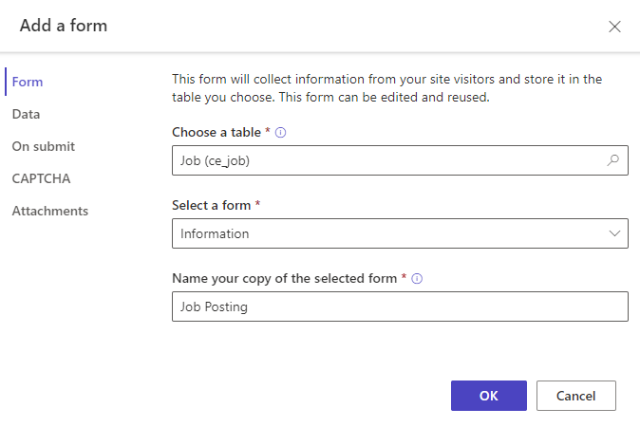

1. Navigate to the **Data** tab of the pop-up window.
2. Enter the following information:
   1. Data from this form: Is read-only
3. Click **OK.**
4. Click **Sync** in the upper right corner of the window. This saves the form to Dataverse.

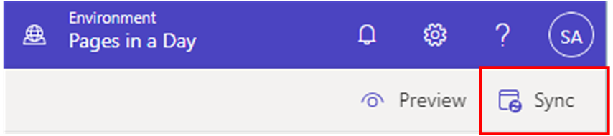

1. Select the form that you just added and, in the options bar, select the ellipses **(…)** and click **Delete**. We will use the form again later, as it has already been created in Dataverse and **Delete** is just removing the component from the web page.
2. Select **Preview > Desktop** in the top right of the window to browse your changes.
3. Expected result:

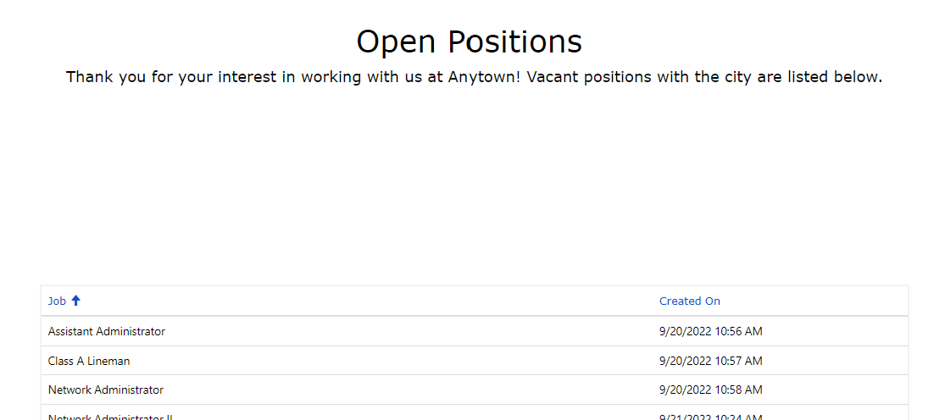

Note: The jobs created in the earlier steps will appear; however, no records in the list are clickable

1. Navigate back to the **Design Studio** tab of your browser.
2. Select the **List** that you already added to the page.
3. Select **Edit list** in the options bar.

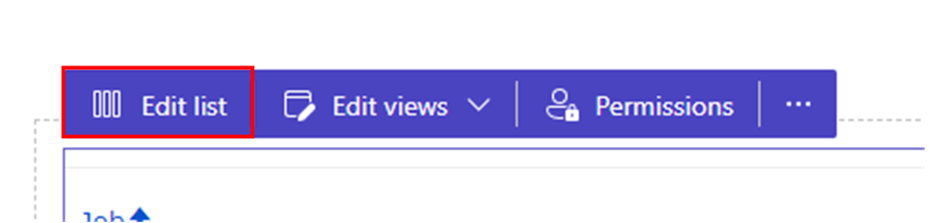

1. Navigate to the **Actions** tab and toggle **View details** on.
2. Enter the following information:
   1. Target type: Form
   2. Form: Job Posting

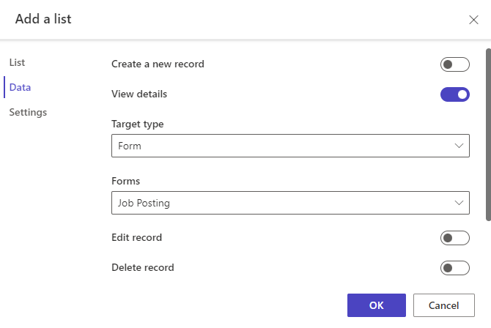

1. Click **Done.**
2. Select **Preview > Desktop** in the upper right corner of the window.
3. On your web page, select the title of job posting from the list displayed. A pop-up window will appear with the details of the job posting. Expected results:

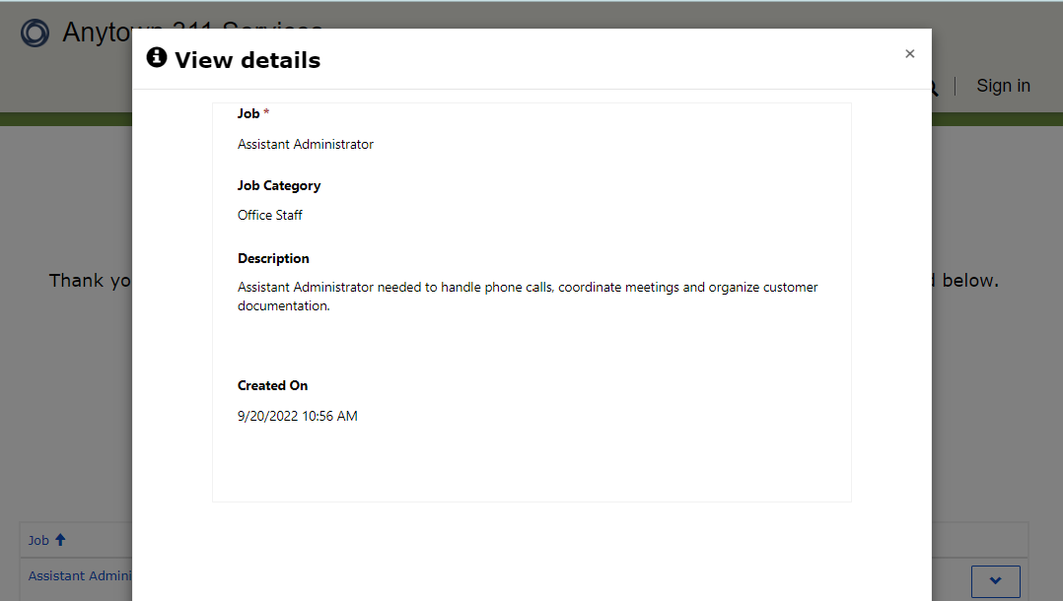

1. Navigate back to the Design studio.
2. Select the ellipses **(…)** and then **Portal Management** from the left navigation bar.

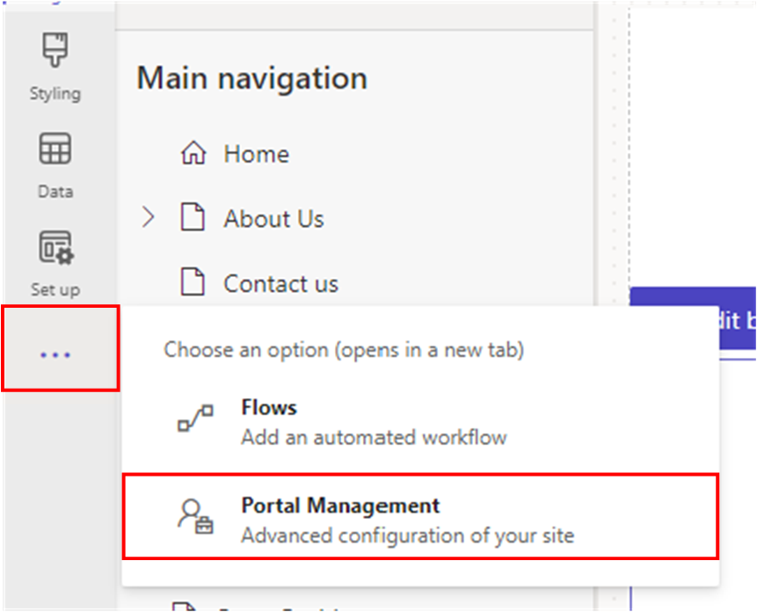

1. From the left navigation bar, click on **Lists** beneath the **Content** section.
2. Note that a new list record has been created corresponding to what you just created in the **Design** **Studio**.

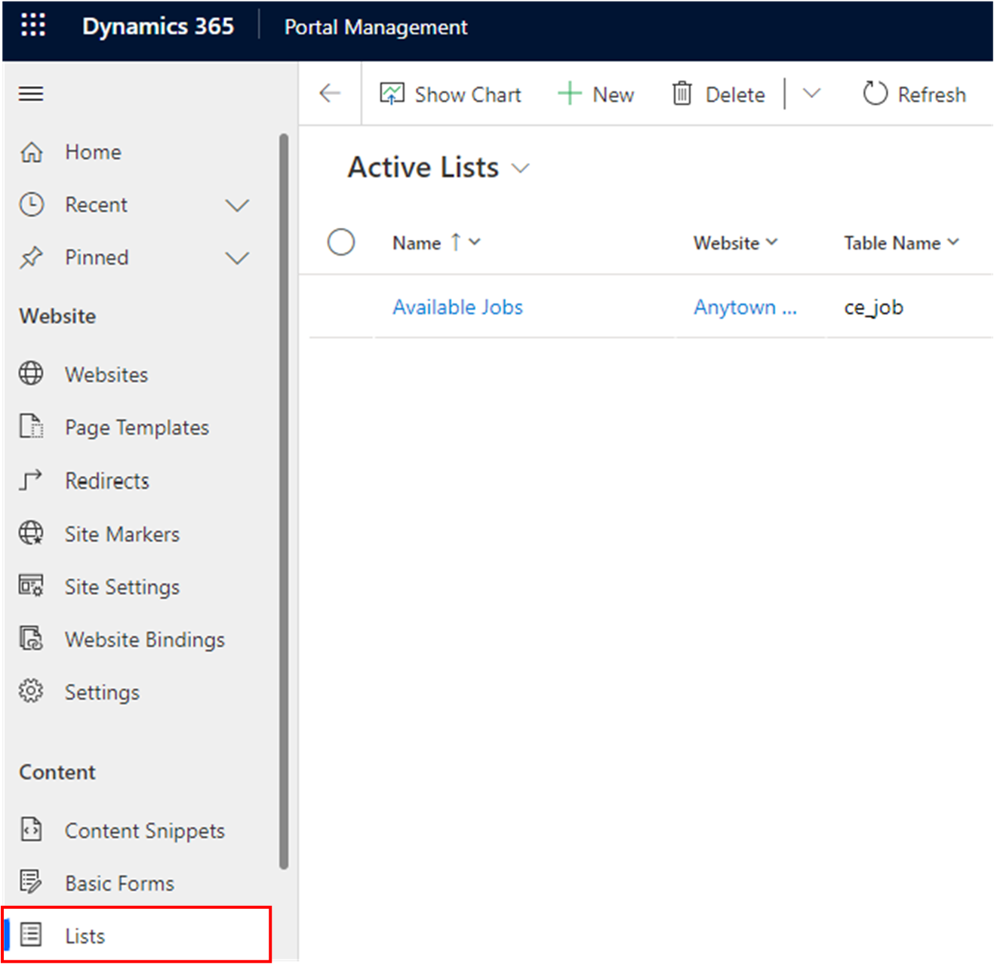

You have completed Lab 3.